

Truffle Quality Control Standards

FINAL VERSION
Contact details for the authors:
Dr Ian R. Hall, Truffles & Mushrooms (Consulting) Ltd, P.O. Box 268, Dunedin, New Zealand. Telephone +64-3-454 3574, +64-27-226 1844, truffle1@ihug.co.nz, www.trufflesandmushrooms.co.nz

Mrs Patricia Nelson, 8 Upland Road, Remuera, Auckland, New Zealand, gpetal@ihug.co.nz

Ian R. Hall and Patricia Nelson

20 April 2008

Copies can be downloaded from

www.trufflesandmushrooms.co.nz/page15.html

Contents
1 Introduction 3
2 Fraud and quality control of truffles 4
3 United Nations quality standards 4
4 2006 French quality control standards 6
5 Proposed Australia-New Zealand standards for truffles 9
5.1 Definition of produce 9
5.2 Provisions concerning quality 9
5.3 Provisions concerning sizing 10
5.4 Provisions concerning presentation 10
5.5 Provisions concerning labelling 11
6 Annex - Non-Exhaustive List of commercialised truffles 11
7 New Zealand export requirements and certification of exporters 12
8 References 13
9 Acknowledgements 13
Appendix 1. Truffle quality standards from a United Nations document published in 2004. 14
Appendix 2. New French quality standards 17

Introduction
If New Zealand is to become a serious exporter of Périgord black truffle it will need to be able to produce a consistent supply of good quality truffles. This will require the development of large areas of productive truffières and a well established method of ensuring the quality of the truffle. Without both of these in place New Zealand will be unable to meet the quantity and quality requirements needed for an export business.
This report summarises Quality Control Standards being used overseas and those being considered for New Zealand. It assumes that the reader is aware of the problems that can be experienced with the identification of truffles and has read either Taming the Truffle by Ian Hall, Gordon Brown and Alessandra Zambonelli (2007) or the report “Identification of black truffles - Périgord black truffle (Tuber melanosporum), winter truffle (Tuber brumale), Burgundy truffle (Tuber aestivum), and Chinese truffle (Tuber indicum) by Ian Hall, Alessandra Zambonelli and Patricia Nelson.

Fraud and quality control of truffles
Over the past few decades there have been numerous instances of fraud in the truffle industry that have included the substitution of inferior flavoured species such as winter truffles (Tuber brumale) and Chinese truffles (e.g. Tuber indicum) for Périgord black truffles (Tuber melanosporum) and various bianchetti for Italian white truffles (Tuber magnatum) (e.g. http://dezso.klebercz.hu/arc_genetic_coding.htm, http://query.nytimes.com/gst/fullpage.html?res=9407E7DC103BF935A35751C0A9629C8B63, http://query.nytimes.com/gst/fullpage.html?res=990CE5DE153AF936A25751C0A963958260 ).
In New Zealand in the 1990s the masters of industry might have considered a non-interventionist approach and allow the market to decide. Within New Zealand it does appear that the market has been quick to recognise good truffles and to voice opinions when they have not met expected standards. However, such criticism, particularly in print in, for example, a major international newspaper, could take years for New Zealand or any other southern hemisphere country to recover from. Consequently, if New Zealand is to become a serious exporter of truffles it will be essential that exported truffles meet standards demanded by international markets.

United Nations quality standards
Some standards were published three years ago by the United Nations (2004). This document is available on line but for convenience it is included as Appendix 1. However, if you need to cite these standards please be sure to use the original source exactly as it appears in the list of references at the end of this document.
The UN standards have phrases in them that suggest they have been translated from French quite probably from the precursor of new French standards that were published in Le Trufficulteur in December 2006 (Vignaud 2006). These new French standards, which have been under discussion since 2004, will remain in force until 2009. They contain some notable changes such as the legal dates for harvesting truffles in France (Table 1).

Table 1. The first two columns of this table are as they appear in the United Nations document. Ian Hall has added the third which are common names more likely to be used in English speaking countries. The fourth column are Alessandra Zambonelli and Ian Hall’s gourmet ratings. The fifth column contains the dates for commercialising truffles as listed in Article II of the 2006 French standards .
Species | Commercial type | Common English names | Gourmet rating (also see section 2.1) | Allowable dates in France for commercialization – can be modified from region to region
Tuber melanosporum Vittadini | Black truffle | Périgord black truffle | *** | 15 November to 31 March
Tuber brumale Vittadini | Brumal truffle | winter truffle | * | 15 November to 31 March
Tuber brumale Vittadini var. moschatum Ferry de Bellone | Musky truffle | winter truffle | * | 15 November to 31 March
Tuber indicum Cooke et Massee | China or Asia truffle | Chinese truffle
Tuber aestivum Vittadini | White summer truffle | Summer (Burgundy) truffle | * | 1 May to 30 November
Tuber uncinatum Chatin = T. aestivum | Burgundy truffle | Burgundy truffle | ** | 15 September to 15 January
Tuber mesentericum Vittadini | ‘Mésentérique’ truffle | Bagnoli truffle |  | 15 September to 15 January
Tuber magnatum Pico | White truffle of Piedmont | Italian white truffle | ***
Tuber borchii Vittadini | Blanquette truffle | bianchetto | ** | 15 January – 15 April
Tuber macrosporum Vittadini | Smooth truffle | smooth truffle | ** | 1 September – 31 December
Tuber gibbosum Gilkey | Truffle of the Oregon | Oregon spring white truffle | **

2006 French quality control standards
Below is a loose translation of parts of Vignaud’s (2006) Le Trufficulteur article (Appendix 2).

Article 1: Objectives
This interprofessional agreement has the aim of defining a standard for fresh truffles, (collected in plantations and from the natural environment) in order to improve the quality of truffles belonging to the genus Tuber produced in France.

Article II: Types of fresh truffles
1. The species
See Table 1 above.

2. Provisions concerning quality

A. Minimum characteristics

In all the categories, independently of the particular provisions planned for each category and of the allowed tolerances, the truffles (collected from plantations the natural environment) must:
- be whole,
- without fractures and cuts; pure; a light surface cut is not regarded as a defect,
- to have the odour, flavour and the colour characteristics of the species,
- to have a sufficient maturity, such as truffles fulfil the commercial requirements instead of destination,
- to be firm with the touch,
- clean, to be brushed or washed without ground traces, to be free of parasites and foreign material,
- to be free of rot and deterioration caused by freezing,
- to be free from abnormal external moisture,
- to be of a mass equal to or greater than 5 grams.

B. Grading

Truffles shall be placed in three categories:

(a) Extra grade
Only truffles of the highest quality are classified in this category. Moreover, they must:
- show the characteristics of the species;
- have a round, more or less regular and lobed form; to be free from deterioration caused by pests.
They should not have defects with the exception of:
- very slight surface deteriorations,
- very slight blemishes,
- very slight defects to shape,
- very slight defects of colour,
provided that these do not affect the overall quality of the product, its conservation or its appearance.

(b) Grade 1
Only truffles of good quality are classified in this category. They can, however, have the light following defects, provided that these do not detract from the overall appearance of the product, its quality, conservation, nor presentation:
- slight defects of form, aspect and colour,
- slight surface bruises,
- slight deteriorations caused by pests.

(b) Grade 2
This category contains those truffles not included in the higher categories with the proviso that they have the minimal characteristics.

3. Provisions concerning size

Size is determined by the weight of individual truffles.
- truffles classified in the "EXTRA" Grade should weigh equal to or higher than 20 grams;
- truffles in Grade 1 must have a weight equal to or greater than 10 grams;
- truffles in Grade 2 must have a weight equal to or greater than 10 grams.

4. Provisions concerning tolerances

Marketing truffle species separately is obligatory. However, because of the difficulties in separating species up to 2% of a batch can be of species different from the label provided that they have been collected at the same time. In no case can the different species be of a species not produced in France, for example, Tuber indicum.

Up to 2% by weight of a batch of truffles can be of a category immediately below it.
Up to 2% of truffles by weight can be of a weight in the category immediately below it.
The cumulative weight of truffles in the above exceptions cannot exceed 2%.

5. Provisions concerning presentation

Not translated.

ARTICLE III

Dates of commercialisation

See Table 1 above.

ARTICLE IV

Transitory measures

Not translated

ARTICLE V

Botanical and culinary characteristics of commercial species of truffle.
Not translated but covered in many books on truffles including Taming the Truffle (Hall, Brown & Zambonelli 2007).

ARTICLE VI

Not translated

ARTICLE VII

Present agreement is concluded for marketing years 2006/2007, 2007/2008, 2008/2009.

Proposed Australia-New Zealand standards for truffles

Definition of produce
This standard applies to truffles, i.e. ascocarps (fruiting bodies) from species of the genus Tuber, to be supplied fresh to the consumer, truffles for industrial processing are included. A non-exhaustive list of commercialized truffles is included in the Annex.

Provisions concerning quality
The purpose of the standard is to define the quality requirements of truffles at the export control stage, after preparation and packaging and a recommendation for local sales.
A. Minimum requirements
The truffles must be:
- of New Zealand/Australian (one to be deleted) origin,
- firm, clean, intact - slight superficial cut on whole truffles is not regarded as a defect,
- free from pests and major damage caused by pests, rotting or deterioration such as to make it unfit for consumption,
- free of any visible foreign matter and soil free,
- free from damage caused by frost,
- free of abnormal wetness on the surface, aromas and/or flavours that may indicate decay,
- free of any major physical damage, and
- able to withstand transport and handling and arrive at their destination in a satisfactory condition.
B. Maturity requirements
The aroma must be sufficiently developed and must display satisfactory ripeness for the grade allocated.
C. Classification
The truffles are classified in four classes defined below:

Grade A
Truffles in this class should be of the highest quality. They should be of regular shape and sufficiently mature to have the characteristic aroma, taste and colour of the species, with only very slight damage.

Grade B
Truffles in this class may include those that have been damaged or broken but are sufficiently mature to have the characteristic aroma, taste and colour of the species. They may have some shape imperfections and predator damage. It includes truffle pieces greater than 100 g.
Grade C
Truffles in this class comprise smaller truffle pieces, which have been broken or cut from larger truffles but are sufficiently mature to have the characteristic aroma, taste and colour of the species, but will contain defects and damage marks.
Grade D
Truffles in this class are immature truffles with little or no aroma and primarily aimed at the manufacturing industries.

Provisions concerning sizing
Size is determined by the weight of truffle and is graded into the following bands:
0 – 20 g
20 – 100 g
100 – 250 g
250 - 750 g
Special (750 g +)
Examples:
- A shipment of immature truffles each weighing 0-20 g would be graded D 0-20.
- A shipment of mature truffles each weighing about 500 g would be graded A 250 -750.
- A parcel of badly damaged truffles each weighing about 75 g would be graded C 20-100.
- A mature truffle weighing 1.1 kg would be graded Special A 1.1kg.

Provisions concerning presentation

A. Uniformity
The contents of each package must be uniform and contain only a single species of truffle of the quality, maturity, development, coloration and commercial type stated.
The visible part of the contents of the package must be representative of the entire contents.
B. Packaging
The truffles must be packed in such a way as to protect the produce properly.
The materials used inside the package must be new, clean and of a quality such as to avoid causing any external or internal damage to the produce. The use of materials, particularly of paper or stamps bearing trade specifications, is allowed provided the printing or labelling has been done with non-toxic ink or glue.

Provisions concerning labelling
Each package must bear the following particulars, in letters grouped on the same side, legibly and indelibly marked, and visible from the outside:

A. Identification
- Packer Name and address and/or official dispatcher

B. Nature of produce
- Truffles
- Commercial type or equivalent denomination
- Genus and species (Latin Name), see Annex

C. Origin of produce
- “New Zealand”/”Australia” and, optionally, the district where grown, or national, regional or local place name

D. Commercial specifications
Grade and Net weight
Example: A 1.600kgs when packed (ensure requirement under current NZ/Aust law?)

E. Logo Optional

Annex - Non-Exhaustive List of commercialised truffles

Species Common name
Tuber melanosporum Vittadini Périgord black truffle
Tuber borchii Vittadini Bianchetto
Tuber aestivum Vittadini Burgundy truffle
Tuber magnatum Pico Italian white truffle

New Zealand export requirements and certification of exporters
To ensure truffles have been properly graded and to meet the requirements of the Horticultural Export Authority there will be a need to ensure that exporters are competent in implementing the New Zealand quality control standards and this will involve some form of certification.
It is proposed that the following people will be able to provide instruction on the grading of truffles on the basis of their macroscopic external and internal appearance based on their experience with collecting and assessing mature Périgord black truffles:
Alan Hall
Gavin Hulley
Ian Hall
Wang Yun
Suitably qualified people from overseas
In addition it is proposed that Ian Hall, Wang Yun or international specialists will provide instruction on the identification of truffles from their microscopic features. We suggest that classes be held annually, organised through the NZ Truffle Association and held in conjunction with the AGM. The content of the classes will be at the discretion of the teacher(s).
In Italy the education and certification of people who wish to harvest truffles from the wild is carried out on a user pays basis. Similarly, we foresee the certification of people for identifying and grading truffles in New Zealand will also be on a user pays basis.

References
Davidson, M.W. 2003. Georges (Jerzy) Nomarski (1919-1997). Molecular expressions, Science, optics and you. The Florida State University. http://micro.magnet.fsu.edu/optics/timeline/people/nomarski.html
Hall, I.R.; Brown, G.; Zambonelli, A. 2007. Taming the truffle: the history, lore, and science of the ultimate mushroom. Timber Press. (In press, see Appendix 3)
Montecchi, A.; Sarasini, M. 2000. Funghi ipogei d’europa. Trento, Associazione Micologica Bresadola.
Reyna, S. 2007. Trufficultura - fundamentos y technizas. Valencia, Mundi-Prensa.
Riousset, L.; Riousset, G.; Chevalier, G.; Bardet, M.C. 2001. Truffes d’Europe et de Chine. Paris, INRA. 181 p.
United Nations. 2004. UNECE Recommendation FFV-53 concerning the marketing and commercial quality control of fresh truffles (Tuber). Based on document TRADE/WP.7/GE.1/2004/INF.19. www.unece.org/trade/agr/meetings/ge.01/document/2004_25_a08.pdf
Vignaud, G. 2006. La nouvelle norme “truffes fraîches”. Le trufficulteur. October-November-December. Pp. 11-14.
Zambonelli, A.; Iotti, M. 2005. Appennino Modenese terre da tartufo. Modena, Giorgio Mondadori.

Acknowledgements
We wish to thank Chris Pratt for his input during the early development of these standards.
Appendix 1. Truffle quality standards from a United Nations document published in 2004.
Any references to this document should quote the original source as it appears in the list of references (United Nations 2004). www.unece.org/trade/agr/meetings/ge.01/document/2004_25_a08.pdf

I. DEFINITION OF PRODUCE
This standard applies to truffles, i.e. ascocarps (fruiting bodies) from species of the genus Tuber, to be supplied fresh to the consumer, truffles for industrial processing being excluded. A non-exhaustive list of commercialized truffles is included in Annex.

II. PROVISIONS CONCERNING QUALITY
The purpose of the standard is to define the quality requirements of truffles at the export control stage, after preparation and packaging.

A. Minimum requirements
In all classes, subject to the special provisions for each class and the tolerances allowed, the truffles must be:

- intact; a slight superficial cut is not regarded as a defect,
- firm,
- sound; produce affected by rotting or deterioration such as to make it unfit for consumption is excluded,
- clean, practically free of any visible foreign matter; the residual soil rate must not exceed 5 % by weight,
- free from pests,
- free from damage caused by pest,
- free from damage caused by frost,
- free of abnormal external moisture,
- free of any foreign smell and/or taste.

Truffles must have been carefully harvested.

The development and condition of truffles must be such as to enable them:
- to withstand transport and handling, and
- to arrive in satisfactory condition at the place of destination.

B. Maturity requirements
They must be sufficiently developed, and display satisfactory ripeness.

C. Classification
The truffles are classified in three classes defined below:

(i) "Extra" Class
Truffles in this class must be of superior quality. They must be characteristic of the species.
They must be free from defects with the exception of very slight superficial defects provided these do not affect the general appearance of the produce, the quality, the keeping quality and presentation in the package.
They must have a rounded shape, more or less regular and lobed.
Very slight defects in appearance, in shape and in color are accepted.

(ii) Class I
Truffles in this class must be of good quality.
The following slight defects, however, may be allowed provided these do not affect the general appearance of the produce, the quality, the keeping quality and presentation in the package:
− slight defect in shape,
− slight defect in development,
− slight defect in colouring,
− slight superficial bruising.

(iii) Class II
This class includes truffles which do not qualify for inclusion in the other classes but satisfy the minimum requirements specified above.
The following defects may be allowed provided the truffles retain their essential characteristics as regards the quality, the keeping quality and presentation:
− defect in shape,
− defect in development,
− defect in colouring,
− superficial bruising,
− slight superficial damages caused by pests provided they are not developing.

III. PROVISIONS CONCERNING SIZING

Size is determined by the weight of truffle.
The minimum weight is
− 20 g for Extra Class,
− 10 g for Class I,
− 5 g for Class II.

IV. PROVISIONS CONCERNING TOLERANCES

A. Quality tolerances

(i) "Extra" Class
2 per cent by weight of truffles not satisfying the requirements of the class, but meeting those of Class I or, exceptionally, coming within the tolerances of that class.
(ii) Class I
5 per cent by weight of truffles not satisfying the requirements of the class, but meeting those of Class II, or exceptionally, coming within the tolerances of that class.
(iii) Class II
10 per cent by weight of truffles satisfying neither the requirements of the class nor the minimum requirements, with the exception of produce affected by rotting or any other deterioration rendering it unfit for consumption.

B. Size tolerances
For all classes: 10 per cent by weight of truffles not satisfying the requirements as regards sizing.

V. PROVISIONS CONCERNING PRESENTATION

A. Uniformity
The contents of each package must be uniform and contain only truffles of the same origin, quality, maturity, development, coloration, species and commercial type. The visible part of the contents of the package must be representative of the entire contents.

B. Packaging
The truffles must be packed in such a way as to protect the produce properly.
The materials used inside the package must be new, clean and of a quality such as to avoid causing any external or internal damage to the produce. The use of materials, particularly of paper or stamps bearing trade specifications, is
allowed provided the printing or labeling has been done with non-toxic ink or glue.
Stickers individually affixed on the produce shall be such that, when removed, they neither leave visible traces of glue, nor lead to skin defects.
Packages must be free of all foreign matter.

C. Presentation
The fresh truffles have to be presented in canvas or string bags or other containers which do not affect their quality.

VI. PROVISIONS CONCERNING MARKING
Each package must bear the following particulars, in letters grouped on the same side, legibly and indelibly marked, and visible from the outside:

A. Identification
Packer ) Name and address or
and/or ) officially issued or
Dispatcher ) accepted code mark.

B. Nature of produce
- Truffles
- Commercial type or equivalent denomination
- Species (Latin name)

C. Origin of produce
- Country of origin and, optionally, district where grown, or national, regional or local place name.

D. Commercial specifications
- Class
- Net weight

E. Official control mark (optional)
Published as a new UNECE Recommendation 2004
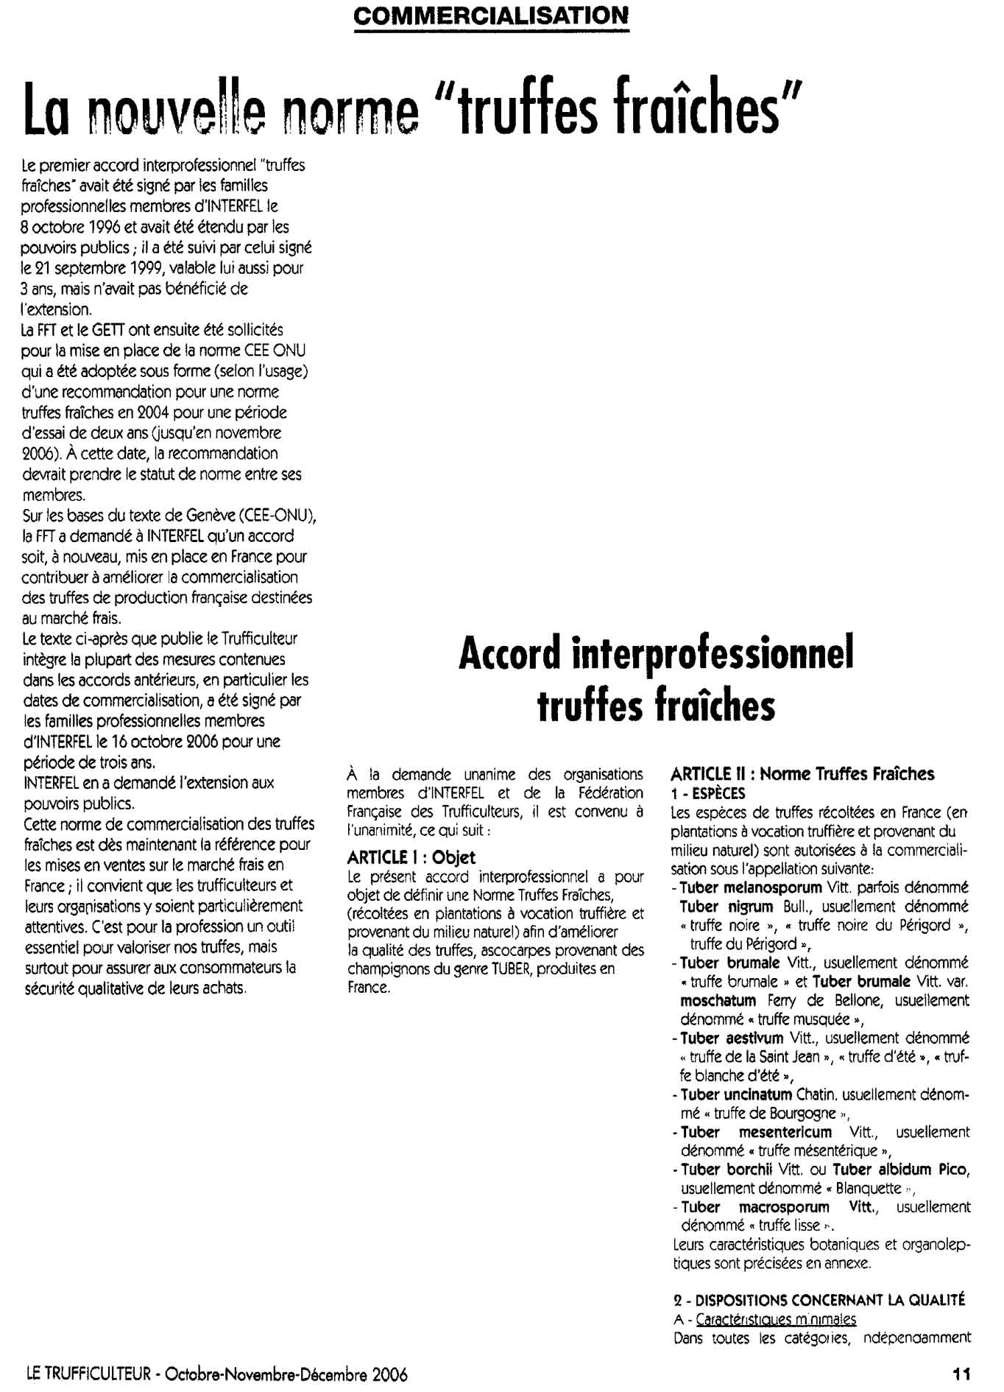
Appendix 2. New French quality standards
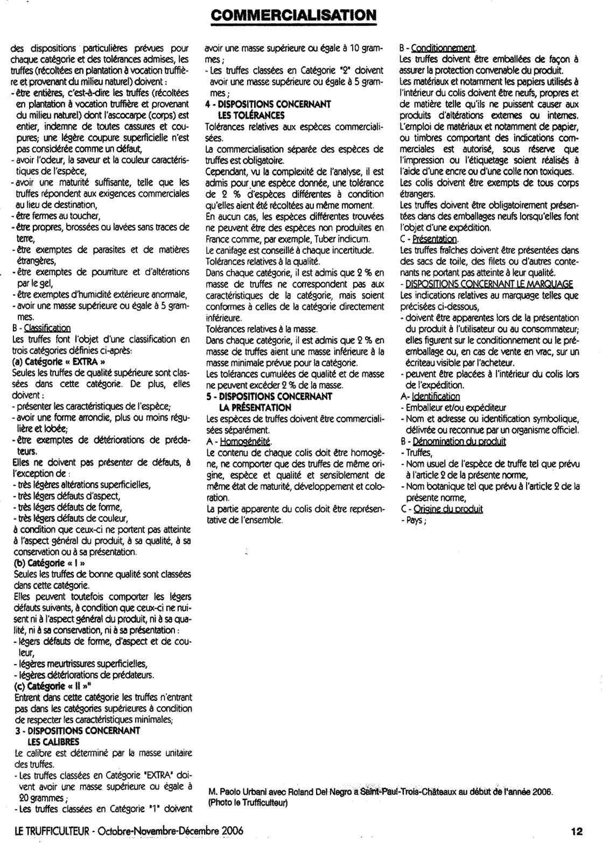
﻿
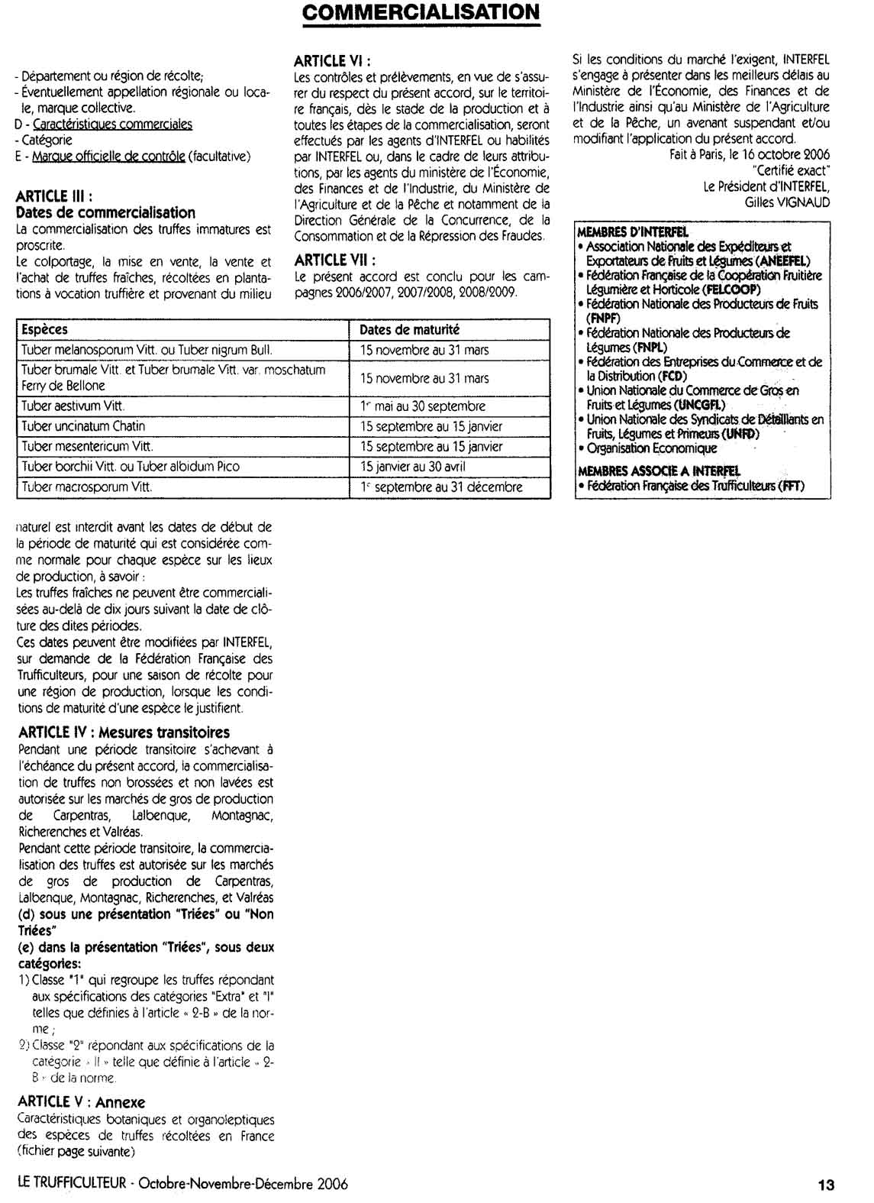

Package units of produce prepacked for direct sale to the consumer shall not be subject to these marking provisions but shall conform to the national requirements. However, the markings referred to shall in any event be shown on the transport packaging containing such package units.
The national legislation of a number of countries requires the explicit declaration of the name and address. However, in the case where a code mark is used, the reference "packer and/or dispatcher (or equivalent abbreviations)" has to be indicated in close connection with the code mark.

